1. **Sales By Customer** :

<https://us1.ca.analytics.ibm.com/bi/?perspective=explore&pathRef=.my_folders%2FSales%2BBy%2BCustomer&subView=model0000018378b810f6_00000000>

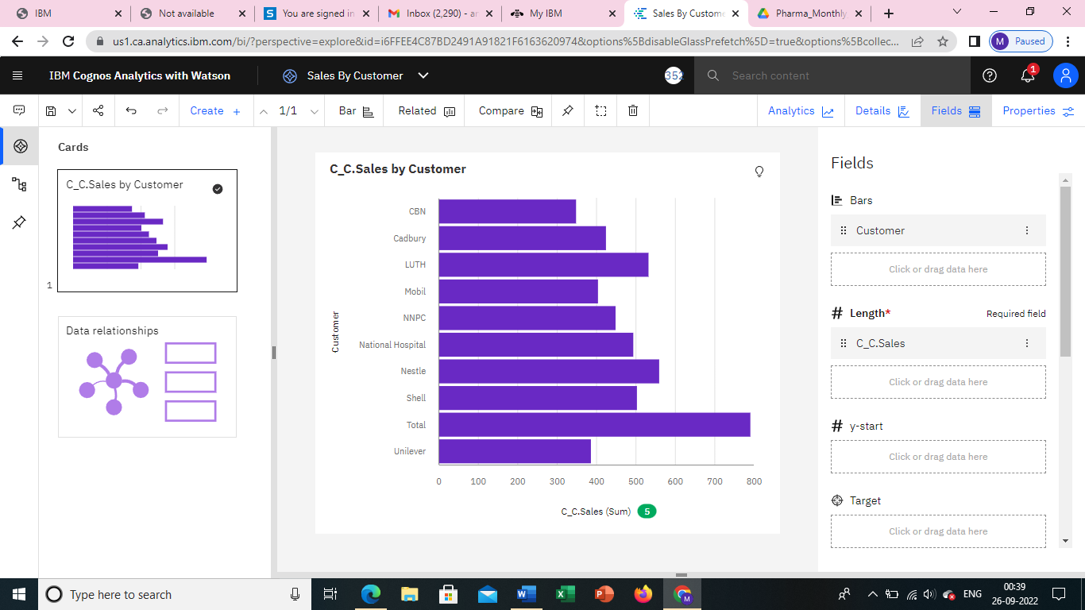

1. **Sales By Location** <https://us1.ca.analytics.ibm.com/bi/?perspective=explore&pathRef=.my_folders%2FSales%2BBy%2BLocation&subView=model0000018378bd768a_00000000>

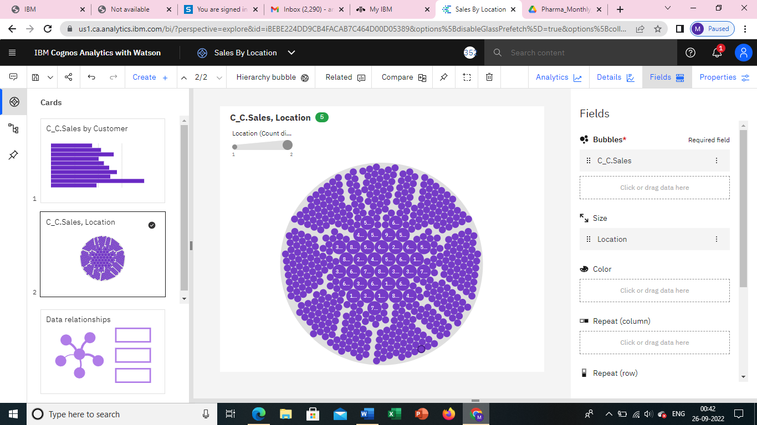

1. **Sales By Sales Representative**

<https://us1.ca.analytics.ibm.com/bi/?perspective=explore&pathRef=.my_folders%2FSales%2BBy%2BSales%2BRepresentative&subView=model0000018378bf78aa_00000003>

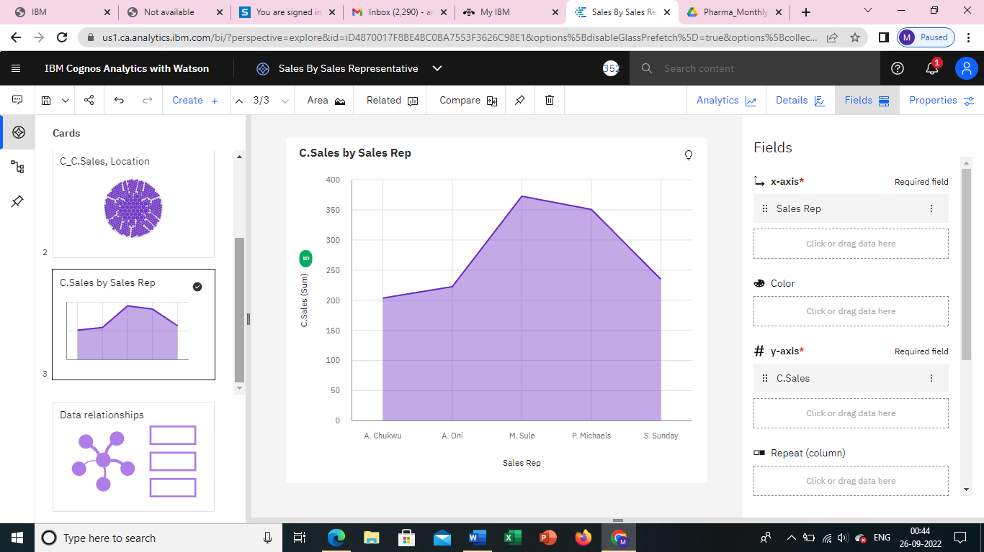

1. **Received Inventory From Supplier** <https://us1.ca.analytics.ibm.com/bi/?perspective=explore&pathRef=.my_folders%2FReceived%2BInventory%2Bfrom%2BSupplier&subView=model0000018378c3680e_00000004>

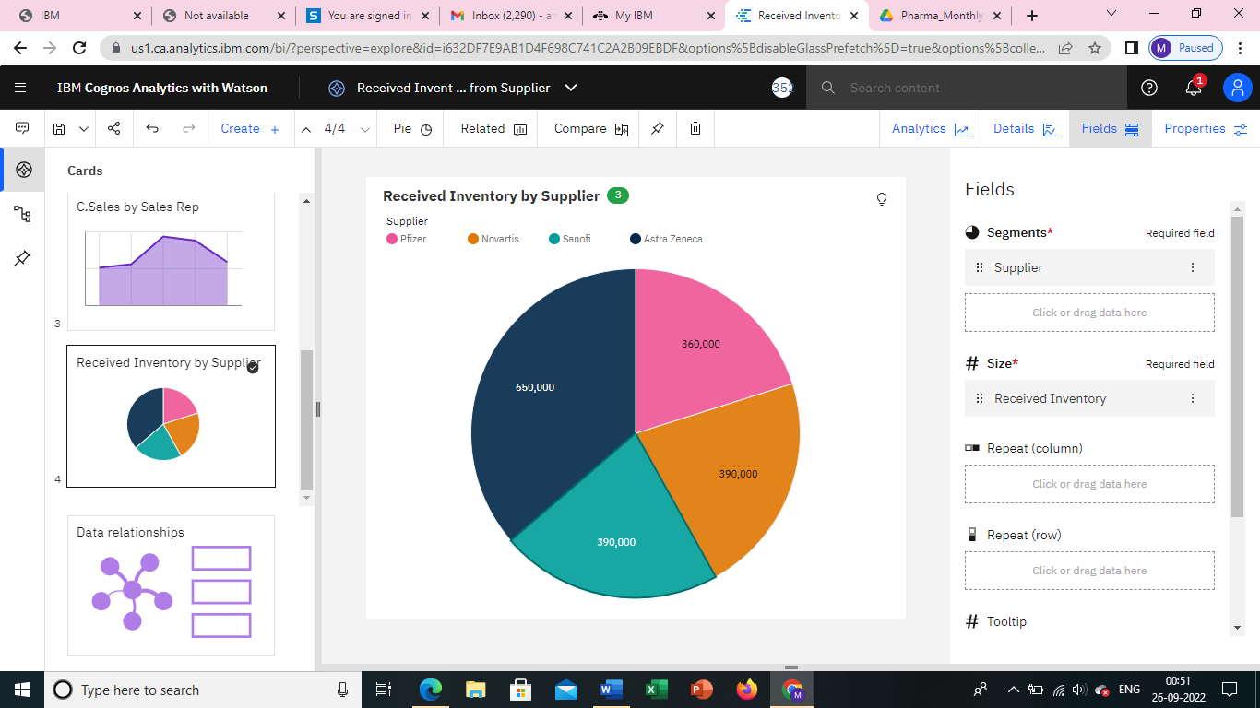

1. **Inventory Stock for Warehouse Locations** <https://us1.ca.analytics.ibm.com/bi/?perspective=explore&pathRef=.my_folders%2FInventory%2BStock%2Bfor%2BWarehouse%2BLocations&subView=model0000018378c8119f_00000000>

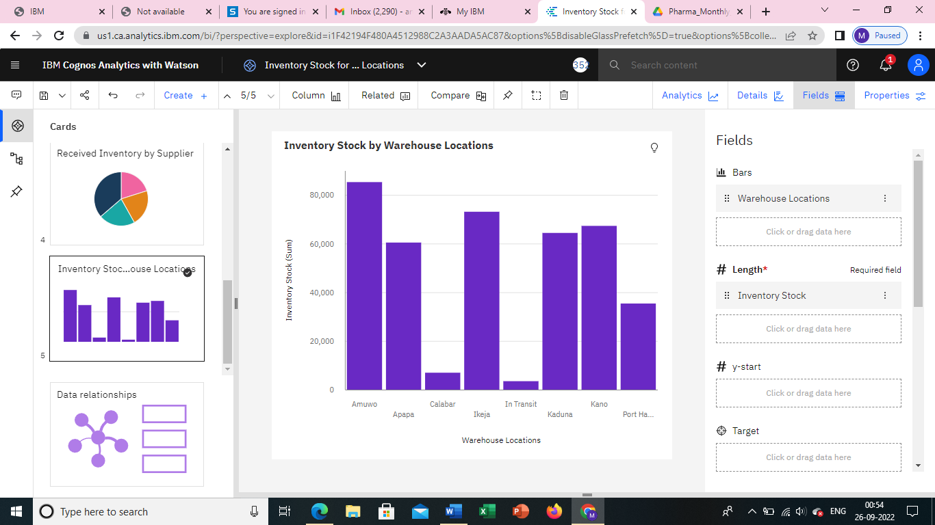

1. **Sales Trend** <https://us1.ca.analytics.ibm.com/bi/?perspective=explore&pathRef=.my_folders%2FSales%2BTrend&subView=model0000018378cad46c_00000003>

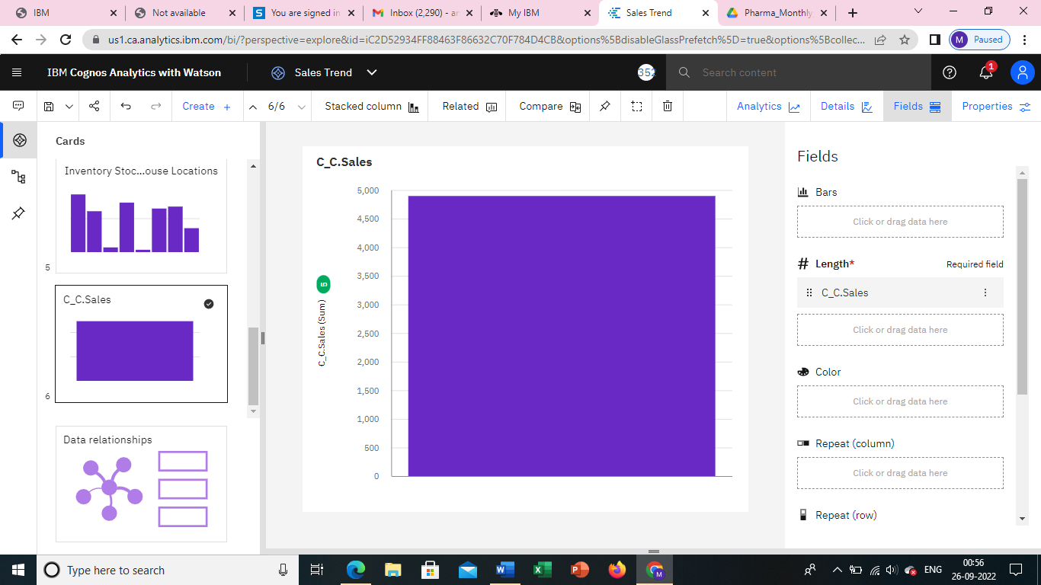

1. **Monthly Sales** <https://us1.ca.analytics.ibm.com/bi/?perspective=explore&pathRef=.my_folders%2FMonthly%2BSales&subView=model0000018378cc8c08_00000004>

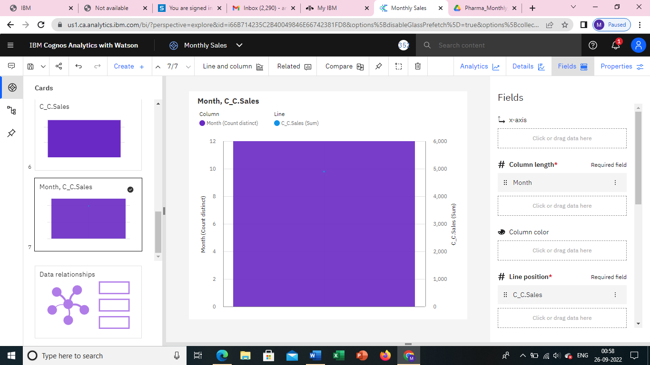

1. **Actual and Received Inventory by Month** <https://us1.ca.analytics.ibm.com/bi/?perspective=explore&pathRef=.my_folders%2FActual%2Band%2BReceived%2BInventory%2Bby%2BMonth&subView=model0000018378ceafca_00000003>

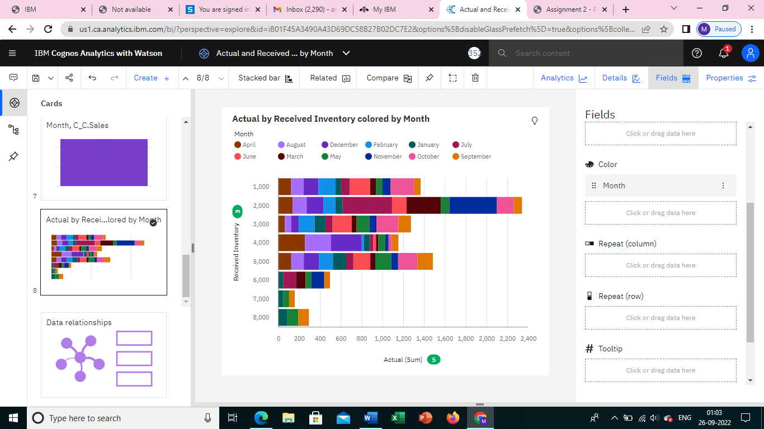

**DASHBOARD**

<https://us1.ca.analytics.ibm.com/bi/?perspective=dashboard&pathRef=.my_folders%2FNew%2Bdashboard%2B1&action=view&mode=dashboard&subView=model00000183795cf876_00000000>

